1. cek x =

if 80<=x && x<=100

then print "A"

else if 75<=x && x<=79

then print "AB"

else if 70<=x && x<=74

then print "B"

else if 65<=x && x<=69

then print "BC"

else if 60<=x && x<=64

then print "C"

else if 50<=x && x<=59

then print "D"

else print "E"

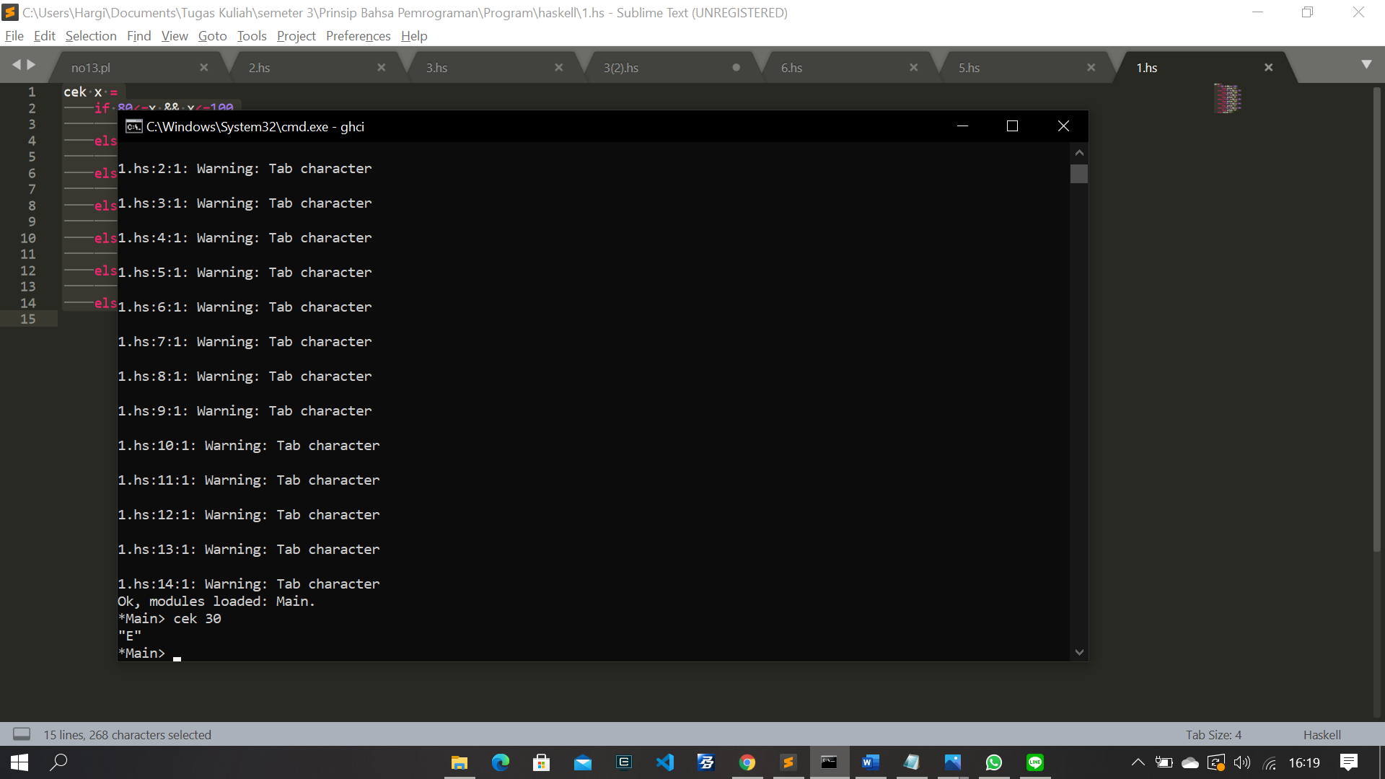

1. module GCD where

gcde a 0 = a

gcde a b = gcde b(a `mod` b)

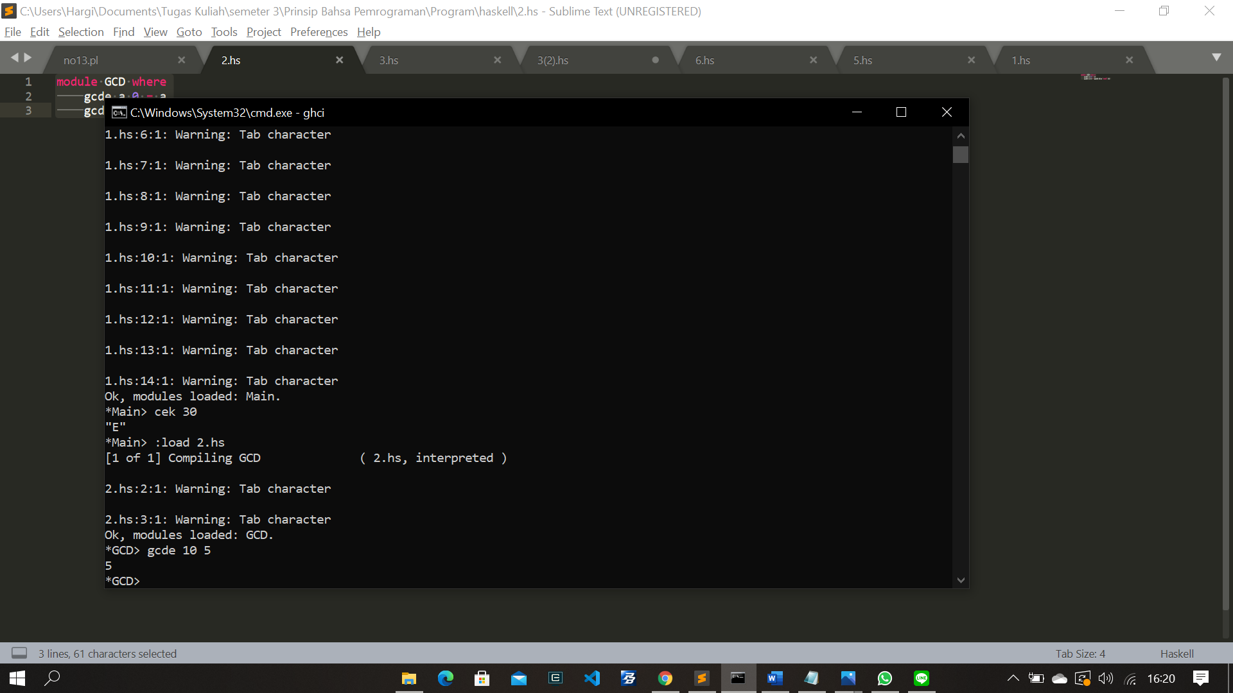

1. checkEvenOdd x = if even x && x>0

then "Genap Positif"

else if even x && x<0

then "Genap Negatif"

else if odd x && x>0

then "Ganjil Positif"

else "Ganjil Negatif"

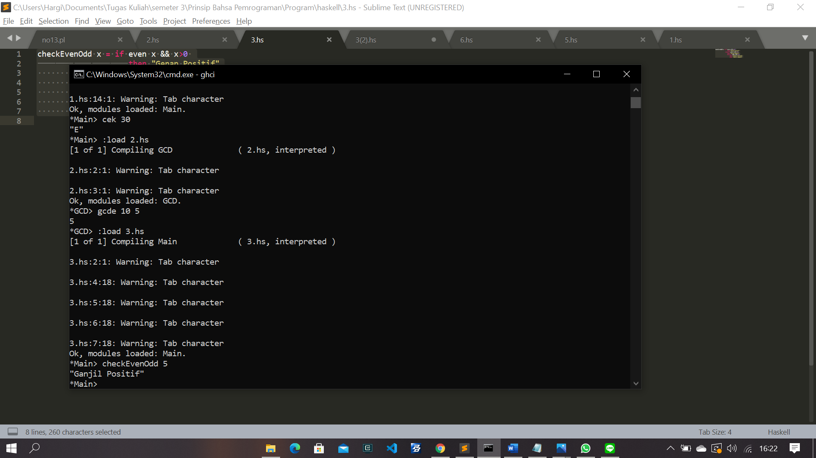

1. module Prime where

isPrime x y =

if y == 1

then True

else if x == 1

then False

else if x `mod` y == 0

then False

else isPrime x (y-1)

cekPrime a = isPrime a (a-1)

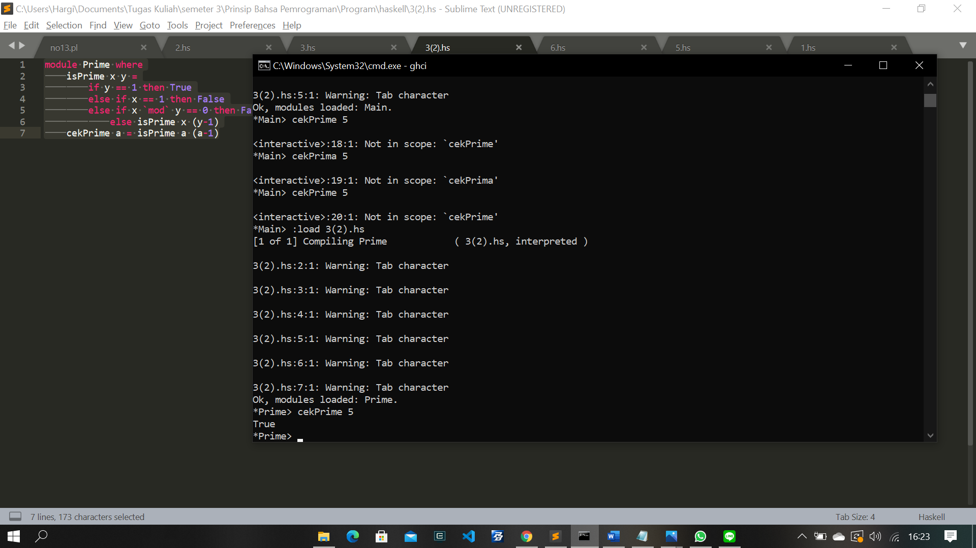

1. –
2. module Prime where

isPrime x y =

if y == 1 then True

else if x == 1 then False

else if x `mod` y == 0 then False

else isPrime x (y-1)

cekPrime a = isPrime a (a-1)

listPrime b = [a | a <- [2..b], cekPrime a]

